
Epacris acuminata
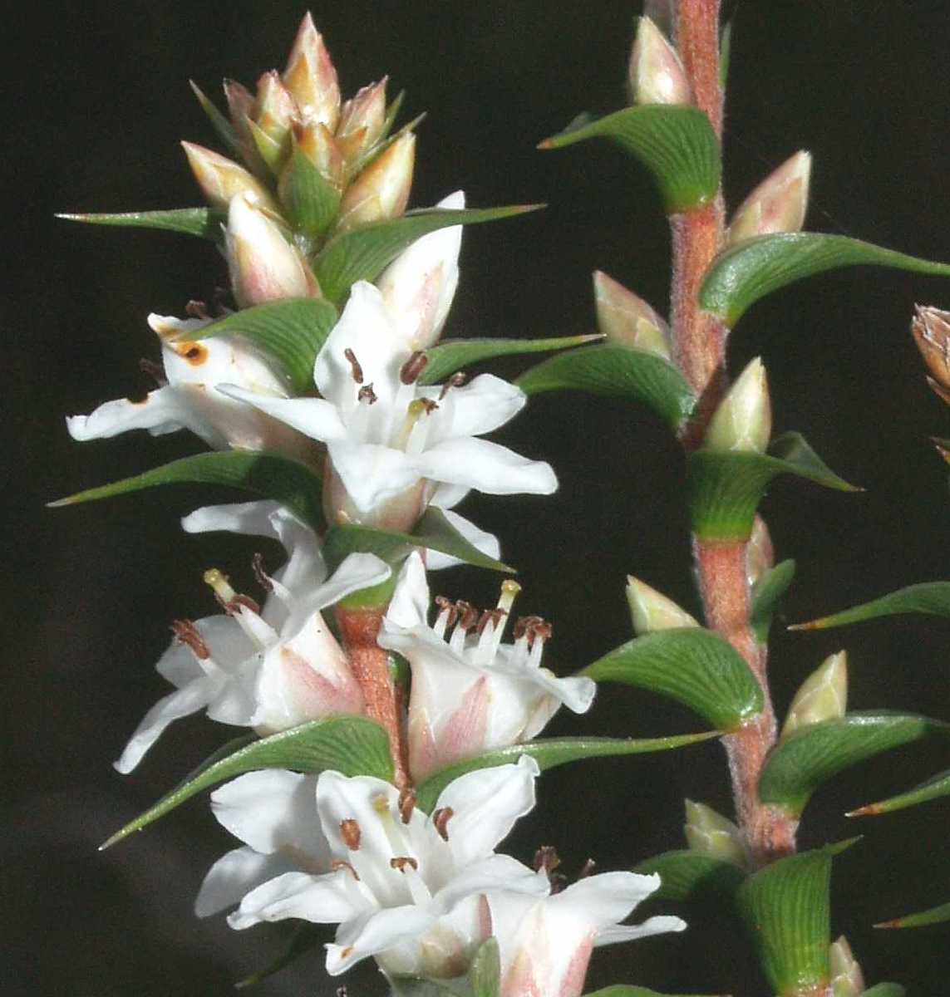
claspleaf heath

T a s m a n i a n F l o r a N O T E S H E E T

Image by Tim Rudman

Scientific name: Epacris acuminata Benth., Fl. Austral. 4: 240 (1868)
Common name: claspleaf heath (Wapstra et al. 2005)
Group: vascular plant, dicotyledon, family Epacridaceae (now Ericaceae)
Status: Threatened Species Protection Act 1995: delisted 2011
Environment Protection and Biodiversity Conservation Act 1999: delisted 2013
Distribution: Endemic status: Endemic to Tasmania
Tasmanian NRM Regions: North, South

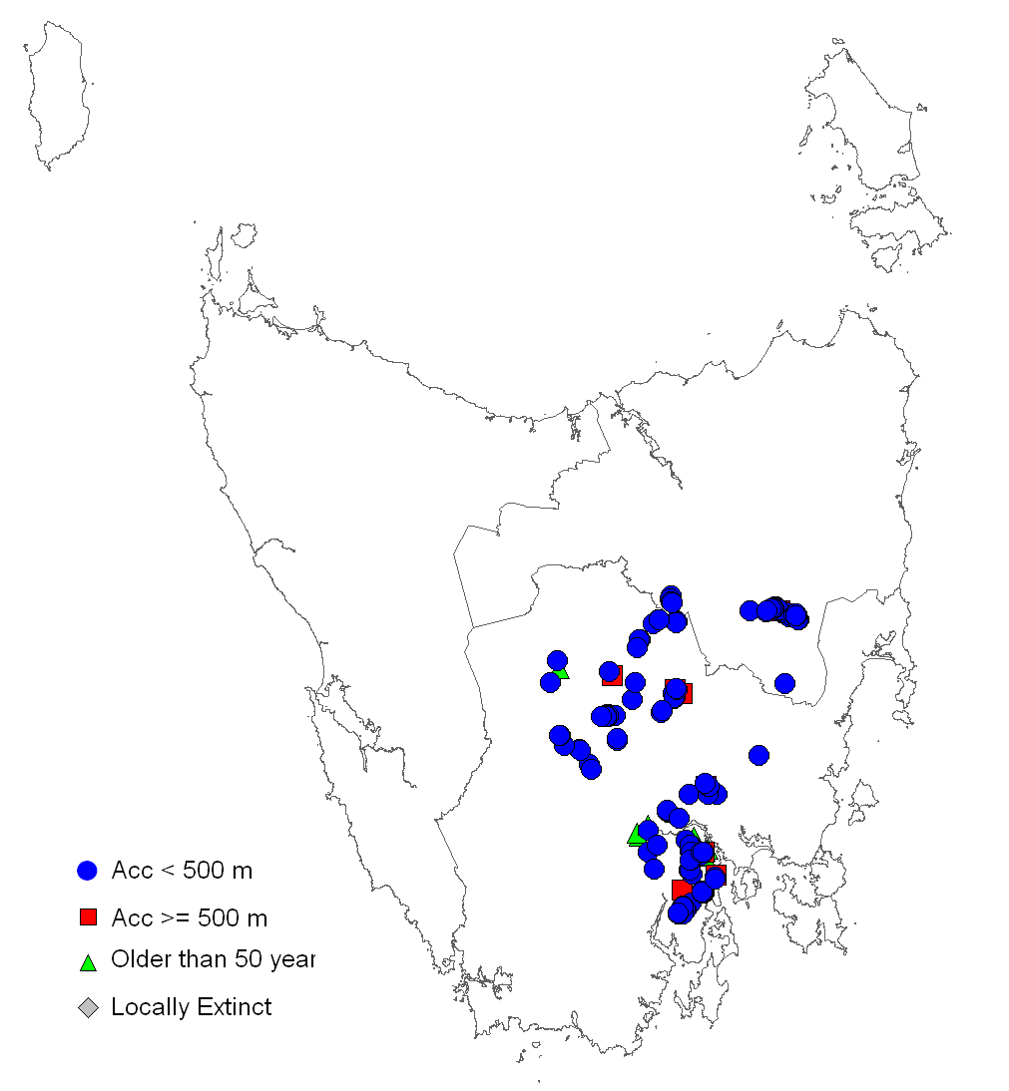 | 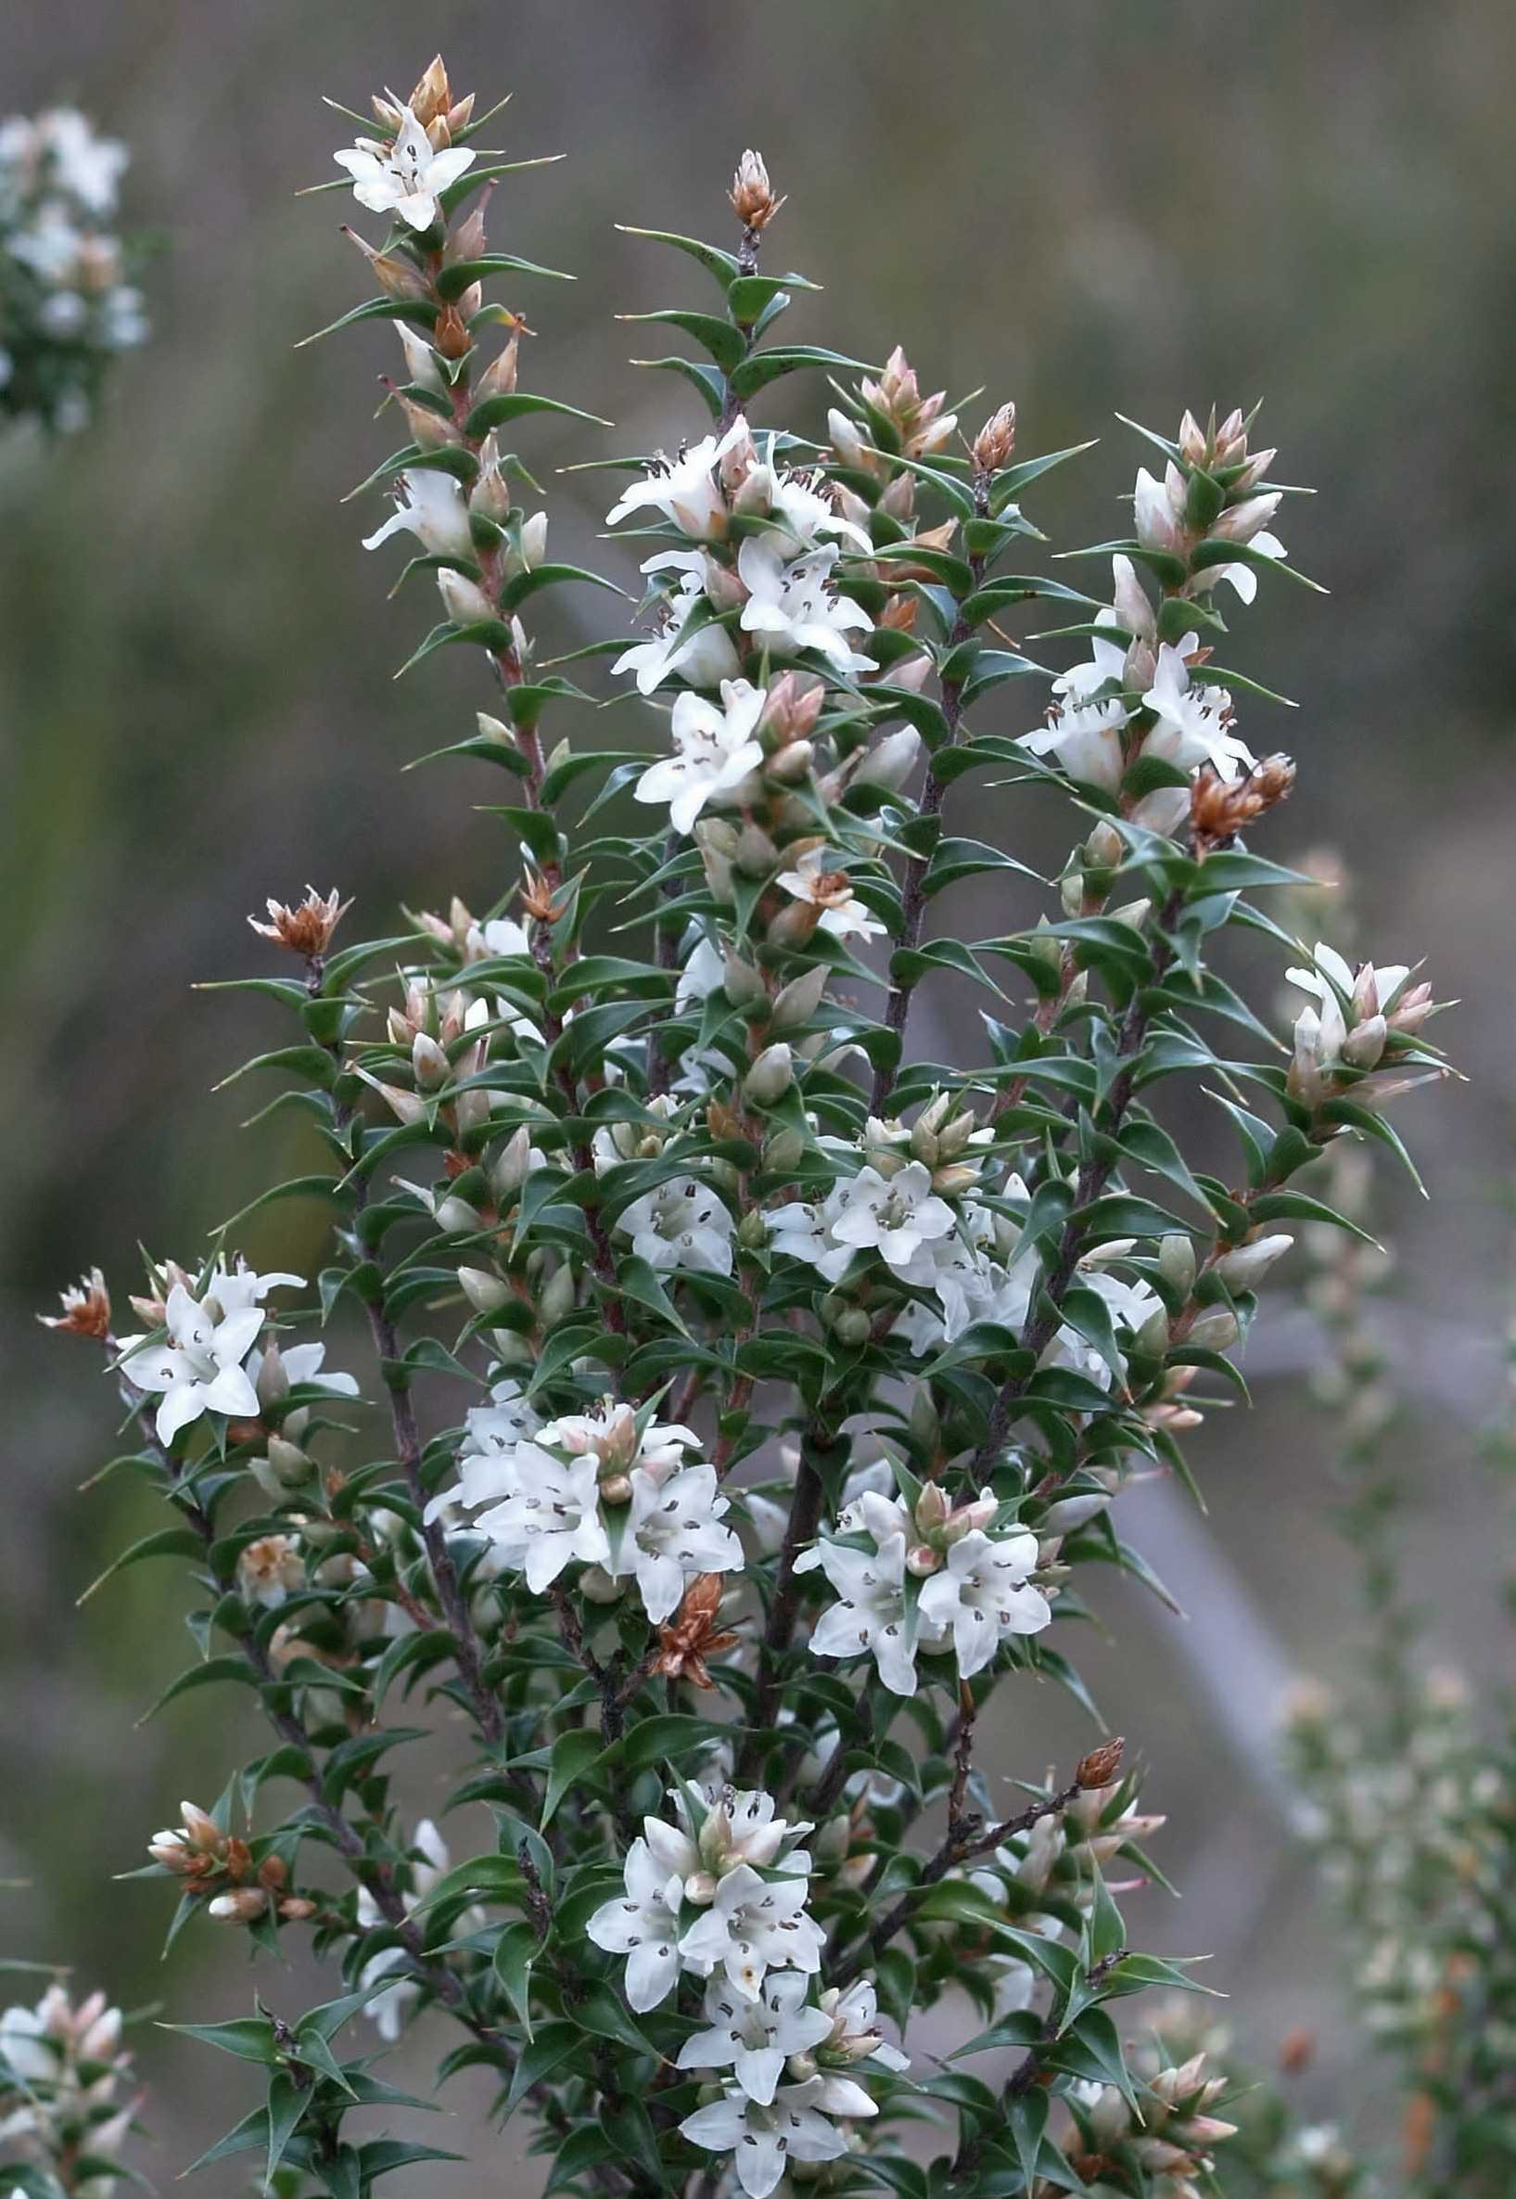
Figure 1. Distribution of Epacris acuminata | Plate 1. Epacris acuminata  (image by Tim Rudman)

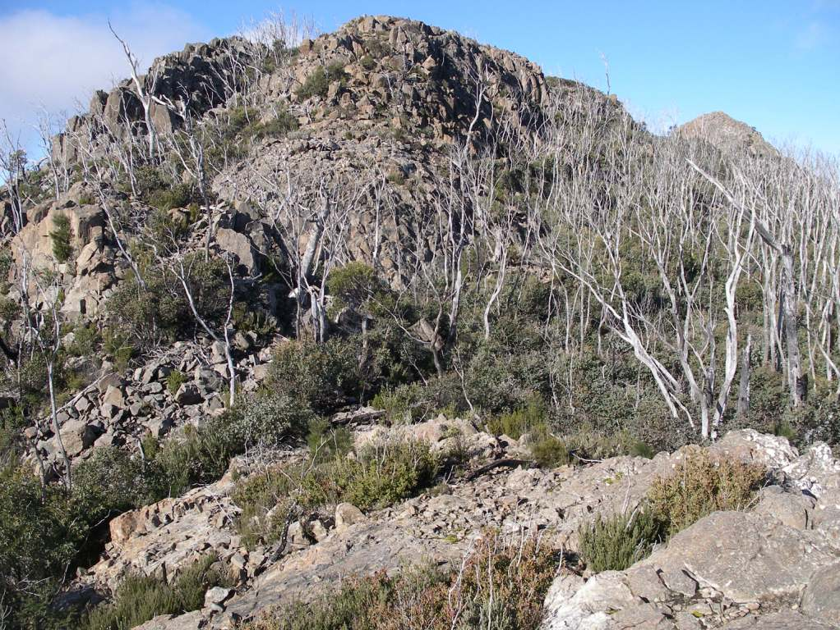
Plate 2. Epacris acuminata habitat: northern end of Platform Peak in 2010, eight years after fire
(image by Richard Schahinger)

IDENTIFICATION AND ECOLOGY
Epacris acuminata is a woody shrub that grows in a range of habitats on dolerite substrates in Tasmania’s southern and central regions. Recruitment is from seed and anecdotal reports suggest that the species may resprout following fire. The maximum life span of individual plants is probably in the order of 30 to 40 years (Keith 1998), with a generation length in the range 8 to 20 years.
Known pollinators of taxa of Epacris include a variety of adult carrion flies from the Tabanidae, Muscidae and Calliphoridae families (Keith 1998). Fruit production for taxa of Epacris depends on plant size, fire history and shading by the canopies of neighbouring plants, with up to several thousand seeds produced each year (Keith 1998). Decreased fruit production may result from predation, browsing herbivores, mechanical damage and high rates of abortion of developing fruits on shaded plants.
Seed release is likely to peak in late summer and be completed by early autumn (Keith 1998). Dispersal is passive. For non-riparian sites very few seeds are likely to be dispersed more than a few metres from their parent plant, though for riparian sites seed may potentially be dispersed several kilometres downstream. The longevity of seed is unknown, although Keith (1998) indicated that appreciable numbers may survive for two years after release into the soil seed bank. The species is likely to produce a fraction of dormant and non-dormant seed each year, thereby accumulating a persistent seed bank. Germination response to heat shock and smoke derivatives results in seedling emergence being cued to the occurrence of fire, although recruitment in riparian situations is likely to reflect the occurrence of flood events.
Survey techniques
Epacris acuminata can be distinguished from other Epacris species at any time of year due to its distinctive foliage (Plate 1), but is most easily detected during its flowering period, July through to late October.
Description
Epacris acuminata is an erect shrub, usually branching near the base, and growing up to
1.5 m tall. Its branches are slender, bearing thin ovate-cordate concave stem-clasping leaves,
4 to 9 mm long and 3 to 5 mm wide, with short (<1 mm long) stalks, an acuminate pungent-pointed apex, and 5 to 7 conspicuous veins on the lower surface. Flowers are white, solitary in the leaf axils, petiolate and densely clustered along the terminal branches. The style is
6 to 8 mm long. The stigma and anthers are exserted from the corolla tube which is
4 to 6 mm long and has 5 lobes that are
4 to 6 mm long. Fruits are capsules up to 2 mm long and are enclosed until dehiscence within imbricate whorls of sepals and bracts.
[description based on Curtis 1963, Keith 1998]
Confusing species
Epacris acuminata can be distinguished from other Epacris species by the combination of stem-clasping leaves and prominently exserted styles and stamens (Curtis 1963).

Distribution AND Habitat
Epacris acuminata is endemic to Tasmania, occurring in the Channel district in the southeast, the Midlands and the eastern edge of the Central Plateau (Figure 1). The species has a linear range of 134 km, extent of occurrence of 8730 km² and an area of occupancy of about 160 ha.
Epacris acuminata grows in low shrubberies around rocky mountain summits (Plate 2), subalpine heathy woodland/forest, ‘moist’ dry sclerophyll forests (Plate 3), and riparian scrubs. The species occurs exclusively on Jurassic dolerite, with a recorded altitude range of 30 to 1100 m above sea level.

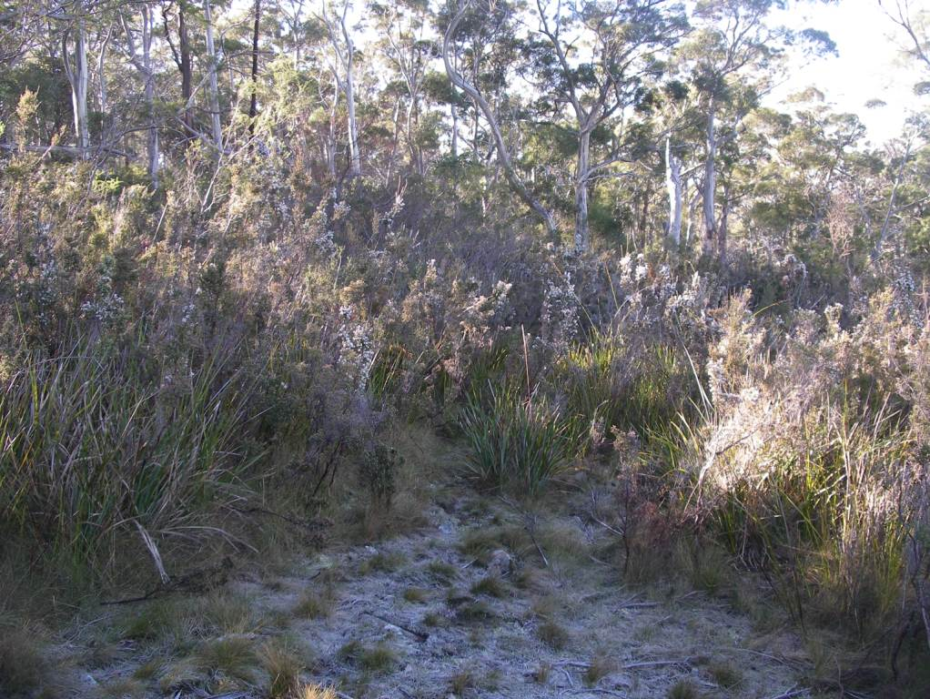
Plate 3. Epacris acuminata at Goat Hills, July 2010 (image by Richard Schahinger)

Population Estimate
Epacris acuminata is known from at least 56 subpopulations, defined as occurrences separated by distances of at least 1 km (Keith 1997). It has a total population size in excess of 500,000 mature plants ± 100,000 (Table 1).
Keith (1997) confirmed 25 subpopulations in 1996 (1 to 25 in Table 1), with a mean estimate of 75,000 mature plants and an area of occupancy of about 85 ha. In the interim another 31 subpopulations have been recorded, with a seven-fold increase in population size. Nine of the ‘new’ subpopulations (26 to 34 in Table 1) represent Tasmanian Herbarium collections that pre-date Keith (1997), including four that were lodged originally as Epacris tasmanica (sensu Curtis 1963); a further nine were the result of pre-logging or dam surveys, two from Hydro Tasmania surveys, two from surveys of private land for potential inclusion in private reserves (54 & 56), two from Bushcare surveys (45 & 48) and the remainder mostly from opportunistic surveys by botanical enthusiasts.
Most of the ‘new’ subpopulations are relatively small, the significant increase in plant numbers since 1996 being a consequence of more comprehensive surveys of known sites including the four largest subpopulations at Goat Hills, Pelverata Falls, Elizabeth River and East Bagdad.
Keith (1997) was unsuccessful in relocating Epacris acuminata at Table Mountain, Mt Faulkner and Moogara though in each case the original collections may have been from nearby known sites (Serat, Kundes Creek and Feilton, respectively). Collections from two of Keith’s ‘unconfirmed’ outlying sites, Elliot Range and Little Split Rock along the upper reaches of the Ouse River, have been re-determined to be Epacris corymbiflora and Epacris serpyllifolia, respectively.
The total population size for Epacris acuminata cited above should be considered a conservative lower estimate, as seventeen of the recorded sites lack quantitative data (Table 1). It is also considered highly likely that additional subpopulations will be discovered given a targeted survey effort, as evidenced by the number of new sites recorded during the past decade.
RESERVATION STATUS
Epacris acuminata is reserved within Wellington Park, Snug Tiers Nature Recreation Area, Mt Dromedary Forest Reserve, Devils Den Conservation Area, Mt Ponsonby Forest Reserve, and possibly Ouse River Forest Reserve and Great Western Tiers Conservation Area. Two sites occur on land covered by conservation covenant under the Tasmanian Nature Conservation Act 2002. Northern occurrences are poorly reserved.
Conservation Assessment
Epacris acuminata was listed as vulnerable on the Tasmanian Threatened Species Protection Act 1995 in 1995. The species was downlisted to rare in 2002, qualifying under criterion B2 (90% of mature individuals occur in 15 or fewer subpopulations or locations and no more than 5 of these occur in an area that is free from sudden processes capable of causing largely irreversible loss of individuals or habitat). The species was delisted in March 2011.
Table 1. Population summary for Epacris acuminata
 | Subpopulation | Tenure | NRM Region | 1:25000 Mapsheet | Year last (first) seen | Area occupied (ha) | Number of mature plants
1 | Grey Mountain,  Snug Tiers | Snug Tiers Nature Recreation Area | South | Cygnet | 1996 (1982) | 0.9 | 1869
2 | Hill at head of Nicholls Rivulet | Snug Tiers Nature Recreation Area | South | Cygnet | 1996 (1987) | 0.2 | 2831
3 | Pelverata Falls,  Snug Tiers | Snug Tiers Nature Recreation Area | South | Huonville | 2004 (1979) | 23.7 | 139498
4 | North West Bay River, Margate | Private land | South | Huonville | 2003 (1981) | 0.2 | 2219
5 | Cathedral Rock | Wellington Park | South | Longley | 2010 (1996) | 0.5 | 4000
6 | Vincents Rivulet | Private land | South | Taroona | 1996 (1975) | 0.2 | 25
7a | Glenorchy Reservoir | Wellington Park | South | Hobart | 2005 (1918) | 0.4 | 111
7b | Humphreys Rivulet | Wellington Park | South | Collinsvale | 2010 (1999) | 1.0 | 1000s
8 | Goat Hills | Wellington Park | South | Collinsvale | 2010 (1931) | 16.7 | 200,000+
9 | Knights Creek | Wellington Park | South | Collinsvale | 2005 (1996) | 0.3 | 600
10 | Molesworth | Private land | South | New Norfolk | 1996 (1986) | 0.01 | 16
11 | Mt Lloyd | State forest | South | Lloyd | 1996 (1985) | 2.5 | 2454
12a | Glenleith, Plenty River | Private land | South | Uxbridge | 2008 (1839) | 1.1 | 100
12b | Feilton, Plenty River | Private land | South | Uxbridge | 2008 (2008) | 0.2 | 150–250
13 | Mt Dromedary | Mt Dromedary Forest Reserve | South | Broadmarsh | 1996 (1989) | 0.3 | 210
14a | Platform Peak | State forest | South | Broadmarsh | 2010  1996  (1984) | 0.8 | 100s  3031
14b | Big Marsh | State forest | South | Broadmarsh | 2010  (2001) | 0  0.3 | 0  10s–100s
15a | Barren Rock Falls | Devils Den Conservation Area | South | Bains | 1996 (1988) | 0.1 | 53
15b | East Bagdad | Devils Den Conservation Area & private land | South | Bains | 2004 (1998) | 7.5 | 50925
16 | Ashton Sugarloaf | Private land | South | Cawood | 1996 (1985) | 0.7 | 1
17 | Derwent River, Wayatinah | HEC | South | Wayatinah | 1996 (1989) | 2.6 | 299
18 | Serat Property | Private land | South | Table | 2006 (1952?) | 4.7 | 12278
19 | Nive River (Marlborough) | Private land | South | Bronte | 1996 (1841?) | 0.1 | 1
20 | River Ouse,  Bashan Bridge | River reserve | South | Steppes | 2007 (1988) | 0.1 | 414
21 | 1.5 km W of Norths Hill | Private land | South | Wihareja | 1996 (1984) | 0.01 | 1
22 | Snowy Knob | State forest | South | Millers | 2005 (1990) | 0.03 | 710
23a | Lake River,  Little Den | Private land & State forest | South | Millers | 2002 (1987) | 0.4 | 1320
23b | Scrubby Den Rivulet | Great Western Tiers Conservation Area/ private land? | South | Millers | 1988 (1988)
24 | Lake River, Caseyville | Private land | North | O'Connors | 1996 (1992) | 4.4 | 128
25a | Elizabeth River, Duckhole Point | Private land | North | Campbell Town | 1996 (1981) | 0.6 | 150
25b | Elizabeth River, East of Chimney Hill | Private land | North | Snow | 2009 (1981) | 65.2 | 73500
26 | Nive River below Clarence River | Private land | South | D'Arcys | 1986 (1986)
27 | Derwent River | Conservation Area/State forest? | South | Strickland | 1987 (1987)
28 | Victoria Valley Falls | State forest | South | Dee | 2010 (1988) | 0.003 | 25
29 | River Ouse | Ouse River Forest Reserve/private land? | South | Cluny | 1989 (1989) |  | ‘Fairly common’
30 | Broad River  (near Cluny Lagoon) | Private land | South | Ouse | 1989 (1989) |  | ‘Fairly common’
31 | Derwent River, Repulse Dam | HEC | South | Ouse | 2010 (1989) | 0.1 | 10s
32 | Macguires Marsh Road,  3 km north of Osterley | Private land | South | Dee | 2009 (1989) | 9.1 | 1000
33 | Fehlbergs Road, Collinsvale | Private land | South | Collinsvale | 2001 (1996) |  | 100s–1000s
34 | Mt Ponsonby | Mt Ponsonby Forest Reserve | South | Woodsdale | 1996 (1996) |  | ‘Locally abundant’
35 | Kundes Creek, Molesworth Road | Private land | South | Collinsvale | 2005 (1996) | 1.5 | 11959
36 | Shannon River (Hermitage) | Private land | South | Hermitage | 1997 (1997)
37 | Arthurs Lake | Private land | South | Arthurs Lake | 1998 (1998)
38 | Billy Browns Falls | State forest | South | Lonnavale | 2000 (1999) | 0.5 | 585
39a | Mt Connection | Wellington Park | South | Collinsvale | 2010 (1999) | 0.4 | 530
39b | Tom Thumb | Wellington Park | South | Collinsvale | 2010 (2000) | 1.0 | 2000
40 | Mt Montagu | Wellington Park | South | Longley | 2000 (2000) |  | 100s–1000s
41 | Perrins Ridge | Snug Tiers Nature Recreation Area | South | Huonville | 2000 (2000) | 0.9 | 500
42 | Snake Point,  Arthurs Lake | Private land/HEC | South | Wihareja | 2000 (2000) | 1.0 | 400–500
43 | Herringback | Private land | South | Huonville | 2000 (2000) | 2.0 | 20
44 | Nive River below Pine Tier Lagoon | Private land | South | Bronte | 2000 (2000)
45 | Shannon River near Blackburn Creek | Public Reserve/ private land? | South | Hermitage | 2001 (2001)
46 | Derwent River,  4 km south of Plenty | Private land | South | Uxbridge | 2001 (2001)
47a | River Clyde,  Dead Mans Hill | Private land | South | Dennistoun | 2002 (2002) |  | 3
47b | River Clyde, near Half Moon Marsh | Private land | South | Dennistoun | 2003 (2003) | 1.0 | 500
48 | Mountain River | Private land | South | Longley | 2002 (2002)
49 | Mikes Hill, Lachlan | Private land | South | Collinsvale | 2003 (2003) |  | 300
50 | Mangalore Tier | Private land | South | Elderslie | 2003 (2003) | 8.0 | 750
51 | Macquarie River, near Maloneys Hill | Private land | North | Faddens | 2003 (2003) |  | ‘Occasional’
52 | Lanes Tier | State forest | South | Dee | 2004 (2004)
53 | Mt Dismal | Private land | South | Bains | 2005 (2005) | 1.0 | 100
54 | Nutshell property, Bagdad | Private land* | South | Bains | 2005 (2005) |  | 1
55 | Derwent River, Catagunyah | HEC/State forest | South | Ouse | 2007 (2006) |  | 205
56 | Flat Rock Reserve, Chauncy Vale | Private land* | South | Bains | 2007 (2007) |  | ‘Sizeable population’
Number of mature plants = mean estimates based on sub-sample counts (Keith 1997 & 1998) and unpublished data held by the Threatened Species Section, Department of Primary Industries, Parks, Water and Environment, Hobart.
* = covered by conservation covenant under the Tasmanian Nature Conservation Act 2002;
HEC = Hydro Electric Corporation; NRM region = Natural Resource Management region

Threats, LIMITING FACTORS AND MANAGEMENT ISSUES
The major threats to Epacris acuminata differ for its three preferred habitats. For riparian sites (21 subpopulations), threats include inundation, regulated flow regimes and woody weed invasion; for dry and moist eucalypt forest (23 subpopulations), threats include land clearance, inappropriate fire frequencies and woody weed invasion; and for mountain summits and rockplates (12 subpopulations) threats include fire and drought.
Inundation and regulated flow regimes: Plants along several rivers are presumed to have been impacted through the construction of hydro-electric dams in the 1950s (Lupton 1999) on the Derwent River, River Ouse, Nive River and Shannon River. Plants are likely to have been destroyed through inundation and changes to the river’s natural flow regimes. Dam construction and regulated flow regimes are potential threats to the subpopulation along the Elizabeth River.
Land clearance: Land clearance in the past has led to the loss of an unknown number of plants, with sites at low to mid-altitudes being especially vulnerable through clearance for agricultural purposes (Serat), subdivision (Fehlbergs Road) or power easements (Goat Hills). Several Forest Practices Plans for land supporting Epacris acuminata have been processed in the past decade though in general, plants have been excluded from forestry operations, and the loss of plants has been relatively small. Future clearance of the species’ riparian scrub habitat is considered unlikely, as this vegetation community is listed as threatened under the Tasmanian Nature Conservation Act 2002.
Weed invasion: the species’ riparian habitat is infested to varying degrees by willow (Salix spp.) and in some instances gorse (Ulex europaeus). The net result has been twofold: direct competition and a decline in recolonisation opportunities. Spanish heath (Erica lusitanica) infestations pose a threat to some of the lowland heathy woodland sites, in particular the Goat Hills and Humphreys Rivulet sites near Glenorchy and the North West Bay River site.
Inappropriate fire regimes: Epacris acuminata is at risk from high frequency fires that interrupt maturation or the development of fire-resistant basal stems in juvenile plants. The effects of adverse fire regimes may be compounded by the failure of seedling recruitment if follow-up rains are not forthcoming, with browsing by native animals further affecting the species’ chances of survival (e.g. Big Marsh and Platform Peak sites). The threat of fire may be greater in the future due to increasingly dry conditions associated with climate change. Conversely, the prolonged absence of fire may lead to local declines or extinctions as plants senesce and soil-stored seed loses its viability. Fire management plans are in place for part of the Goat Hills site in Wellington Park (AVK Environmental Management 2006).
Disease: Epacris acuminata is known to be slightly susceptible to Phytophthora cinnamomi under laboratory conditions (Barker 1994). To date there has been no evidence of the species itself being impacted in the field. However, as in all such cases, the precautionary principle should be invoked until the species’ resistance is demonstrated, and any activities proposed for areas supporting the species should include appropriate disease hygiene measures (DPIWE 2004).
Stochastic risk: Several of the recorded subpopulations support fewer than 500 mature plants and occupy very small areas (Table 1), and are in consequence at risk of extinction due to unforeseen human activities or chance events.

Management Strategy

What has been done?
- an assessment of the species’ status was undertaken during the lead up to the Regional Forest Agreement (Keith 1997);
- the species was included in a Recovery Plan for threatened Tasmanian forest epacrids (Keith 1998), with extension surveys and site assessments undertaken from 2000 to 2002 during implementation of the Plan;
- mapping of occurrences in the eastern sections of Wellington Park were undertaken in 2005 at the behest of the Wellington Park Management Trust, with a discussion of management issues (Schahinger 2006);
- control of spanish heath infestations at the Goat Hills and Humphreys Rivulet sites has been undertaken by the Wellington Park Bushcare group since 2006;
- seed was collected from the Goat Hills subpopulation in 2009 for long-term storage at the Tasmanian Seed Conservation Centre;
- the Recovery Plan for threatened Tasmanian forest epacrids (Keith 1998), which includes the species is currently being revised.
Management objectives
The main objectives for the recovery of Epacris acuminata are to prevent the inadvertent destruction of subpopulations, maintain the viability of existing subpopulations, and promote conditions for the species’ successful recruitment.

What is needed?
- survey sites currently lacking population information to determine their status and management requirements;
- conduct extension surveys of potential habitat, with a particular focus on the Central Plateau and tributaries of the Derwent River;
- support the Private Land Conservation Program (DPIPWE) with the establishment of conservation covenants and management agreements for private land supporting the species, and ensure that current priorities for the species are incorporated into the program’s reservation strategies;
- monitor key subpopulations at two-yearly intervals to determine the level of recruitment and/or plant loss to better inform management prescriptions, including the need for active fire management;
- implement disease hygiene measures for any activities proposed for areas supporting the species;
- provide information and extension support to relevant Natural Resource Management committees, local councils, government agencies, development proponents and the local community on the location, significance and management of known subpopulations and areas of potential habitat;
- implement relevant actions for the species in the Recovery Plan for threatened Tasmanian forest epacrids (Keith 1998), and if the species continues to remain listed as threatened, include the species in any revision of the Plan.

Bibliography
AVK Environmental Management (2006). Fire Management Strategy for Wellington Park: Revision 1 March 2006. AVK Environmental Management, Sandford, Tasmania.
Barker, P.C.J. (1994). Phytophthora cinnamomi: The Susceptibility and Management of Selected Tasmanian Rare Species. Forestry Tasmania and Australian Nature Conservation Agency.
Curtis, W.M. (1963). The Student’s Flora of Tasmania. Part 2. Government Printer, Hobart.
DPIWE (Department of Primary Industries, Water and Environment) (2004). Tasmanian Washdown Guidelines for Weed and Disease Control: Machinery, Vehicles and Equipment. Tasmanian Agricultural Contractors of Tasmania, Forestry Tasmania and the Department of Primary Industries, Water and Environment, Hobart.
Keith, D. (1997). The Distribution and Population Status of Rare Tasmanian Forest Epacrids. Unpublished report, Nature Conservation Branch, Tasmanian Parks and Wildlife Service, Hobart.
Keith, D. (1998). Recovery Plan – Tasmanian Forest Epacrids 1999–2004. Tasmanian Parks and Wildlife Service, Hobart.
Lupton, R. (1999). Lifeblood: Tasmania’s Hydro Power. Focus Publishing Pty Ltd, Edgecliff, New South Wales.
Schahinger, R. (2006). Threatened Epacrids in Wellington Park: Distribution & Management. A report prepared for the Wellington Park Management Trust Hobart, Tasmania.
Wapstra, H., Wapstra, A., Wapstra, M. & Gilfedder, L. (2005). The Little Book of Common Names for Tasmanian Plants. Department of Primary Industries, Water and Environment, Hobart.

Prepared in August 2010. Conservation status updated October 2011 to reflect delisting from schedules of the Threatened Species Protection Act 1995.
Cite as: Threatened Species Section (2011) Note Sheet for Epacris acuminata (claspleaf heath), Department of Primary Industries, Parks, Water and Environment, Tasmania.
View: www.dpipwe.tas.gov.au/threatenedspecieslists
Contact details: Threatened Species Section, Department of Primary Industries, Parks, Water & Environment, GPO Box 44 Hobart Tasmania Australia 7001. Phone (03) 6233 6556; fax (03) 6233 3477.

